**Game-Feel Research**

“Game feel” is a phenomena that could be defined as “virtual stimulation;” it is how visual, aural and physical stimuli from a game cause responses from the player. These stimuli could be used to emphasise an effect or to provide the player with more tangible feedback for an action.

Steve Swink, an independent game developer, states that game feel can be divided into three sub-categories: Real-time control, spatial simulation and polish.

Real-time control, as you would expect, refers to instantaneous and meaningful control over what’s happening on screen. *Starcraft* is a prime example of this, as the core mechanics of the game revolve around the player giving their units commands and adapting those commands as the gameplay changes throughout a match.

Spatial stimulation is the simulated interactions in a virtual space. Sandbox or “sim” games, such as *Surgeon Simulator* are examples of this, as the player is encouraged to experiment with the tools at their disposal and how they interact with each other in order to proceed.

Polish is the refined effects in a game-visual effects such as particles and aural effects such as sounds-that give an action more impact or weight. Action games such as *Devil May Cry* use these, for example glowing edges along the screen and heavy use of particle effects for strong hits to emphasise to the player that they achieved a large combo.

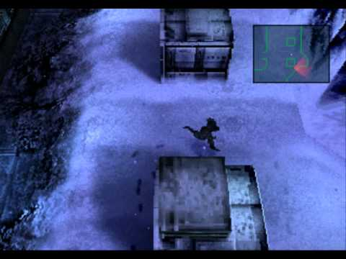

Figure 1: Snake's footprints leave visible marks on the ground that the enemy soldiers will follow to find him.

In *Metal Gear Solid*, one of the many ways it achieved acclaim was due to the several ways for spatial simulation to be expressed. One of the most iconic examples is the heliport, the second screen of the game, where if Snake decides to evade detection by going to the rightmost area, then the guards will discover his footprints and track them to find Snake. For 1998 standards, this level of detail was previously unheard of, and resulted in many players getting a game over within the first half an hour of playing.

In the game *Resident Evil 2*, polish is used to create fear. Once certain conditions are met, the player will be constantly stalked by a monster named “Mr X,” who is unkillable-and in turn can kill you in a single hit-and always patrolling the police station the game takes place in. In order to give the player some leeway, the player will be able to hear his footsteps when he is in a nearby room, and these footsteps will become louder the closer he is, giving the player a precious few seconds to plan a way past him without being seen. This is a unique use of sound in games, and enhances the atmosphere of the game dramatically as the player is always under the threat of being found and attacked.

For our project, interaction between the player and the virtual environment is what I would consider the most important factor. As there are stealth elements to our game, the way the enemy guards interact to seeing the player character (and how the player can avoid detection) are vital to providing an enjoyable experience for the player, as they can be given room to experiment while playing.